**NAME: Kanak Agrawal**

**DAY 3- Assignment(sql_Day)**

**---DDL Command**

1. **CREATE**

**Description:** To create a Table.

**Query:** create table customers

(

customerID int primary key,

customerName varchar(50),

contactName varchar(50),

address varchar(50)

);

**Output:**



1. **ALTER**

**Description:** To make the changes after the creation of a table.

**Query:** alter table customers

add pincode varchar(50);

**Output:**

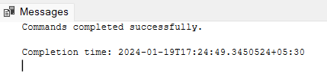

1. **DROP**

**Description:** To delete a particular column or a table.

**Query:** alter table customers

drop column pincode;

**Output:**

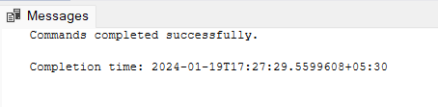

**Description:**

**Query:**

**Output:**

1. **TRUNCATE**

**Description:** This command deletes the data inside a table, but not the table itself.

**Query:** truncate table customers;

**Output:**



**---DML Command**

1. **SELECT**

**Description:** To show the details of the table.

**Query:** select * from employee;

**Output:**

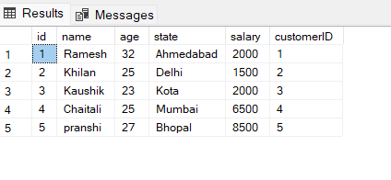

1. **INSERT**

**Description:** To insert the data in the table.

**Query:** INSERT INTO employee VALUES

(1, 'Ramesh', 32, 'Ahmedabad', 2000.00,1),

(2, 'Khilan', 25, 'Delhi', 1500.00,2),

(3, 'Kaushik', 23, 'Kota', 2000.00,3),

(4, 'Chaitali', 25, 'Mumbai', 6500.00,4),

(5, 'Hardik', 27, 'Bhopal', 8500.00,5);

**Output:**



1. **UPDATE & SET**

**Description:**  To update some of the data after entering the previous data.

**Query:** update employee

set name='pranshi'

where id =5;

**Output:**

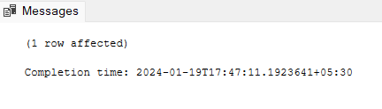

1. **DELETE**

**Description:** To delete some data or column.

**Query:** delete from employee

where id =6;

**Output:**

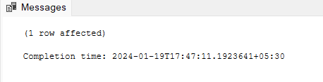

1. **JOINS & GROUP BY**

**Description:**  To join the two tables and then arrange by groups accordingly.

**Query:** select

C.customerID,

C.customerName,

E.salary

from customers as C

join employee As E

on C.customerID=E.customerID

group by C.customerID,c.customerName,E.salary;

**Output:**

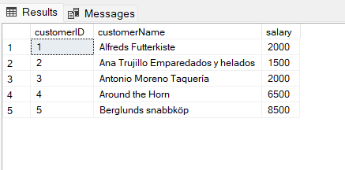

**--ASSIGNMENT(SQL_D)**

**PET ADOPTION**

1. **Create Table For Animals**

**Query:** create table animals

(

id int primary key,

name varchar(50),

breed varchar(50),

color varchar(50),

gender varchar(50),

status int

);

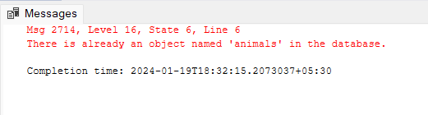

1. **Create Table For Adoptions**

**Query:** create table adoptions

(

animal_id int foreign key

references animals(id),

name varchar(50),

contact int,

date date

);

**Output:**

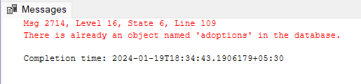

1. **Create Table for Shelters**

**Query:** CREATE TABLE shelters

(

id Int,

name varchar(50),

location varchar(50)

);

**Output:**

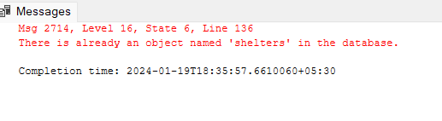

1. **Inserting data for Dog Only**

**Query:** insert into animals values

(1,'Bellyflop','Beagle','Brown','Male',1),

(2,'snowy','Husky','White','Female',0),

(3,'Princess','Pomeranian','Balck','Female',1),

(4,'Cricket','Chihuauhua','Brown','Male',1),

(5,'Princess','poodle','Purple','Female',0),

(6,'Spot','Daimation','balck and White','Male',1);

**Output:**

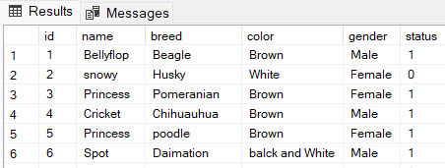

1. **Selecting breed for all the animals**

**Query:** SELECT breed FROM animals;

**Output:**

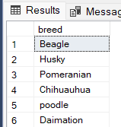

1. **Select the name of the female animals**

**Query:** SELECT name FROM animals WHERE gender = 'Female';

**Output:**

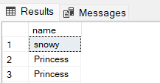

1. **Select the id of the animals whose status is 0(Open for Adoption)**

**Query:** SELECT id FROM animals WHERE status = 0;

**Output:**

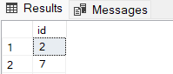

1. **Update the color of the animals using id**

**Query:** UPDATE animals

SET color = 'Brown'

WHERE id = 3;

**Output:**

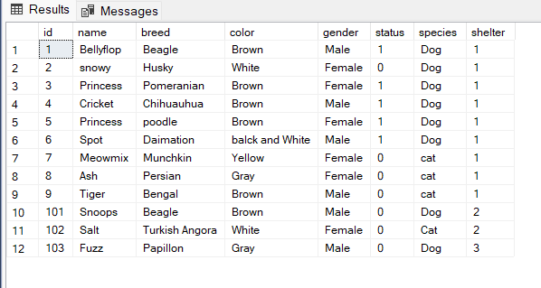

1. **Update the color of the animals using name**

**Query:** UPDATE animals

SET color = 'Brown'

WHERE name = 'Princess';

**Output:**

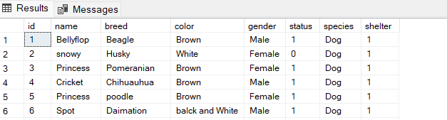

1. **Adding new Column name as Species in Animal Table**

**Query:** ALTER TABLE animals

ADD species varchar(70);

**Output:**



1. **Updating animal and setting species as dog because now we are also adding cat species**

**Query:** UPDATE animals

SET species = 'Dog';

**1Output:**

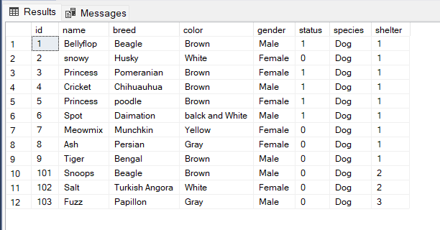

1. **Inserting Data For Cat Species**

**Query:** insert into animals values

(7, 'Meowmix','Munchkin', 'Yellow', 'Female', 0,'cat'),

(8,'Ash','Persian', 'Gray', 'Female', 0,'cat'),

(9,'Tiger','Bengal', 'Brown', 'Male', 0,'cat');

**Output:**

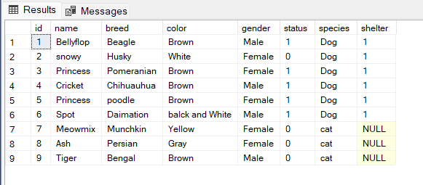

1. **Adding new Column name as shelter**

**Query:** ALTER TABLE animals

ADD shelter INT;

**Output:**



1. **Updating shelter of animal table as 1**

**Query:** UPDATE animals

SET shelter = 1;

**Output:**

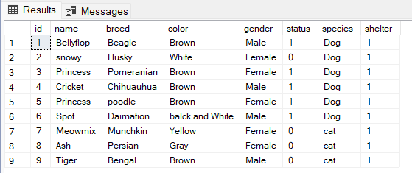

1. **Adding new database in animal table after adding new Columns like shelter, species**

**Query:** INSERT INTO animals (id, name, shelter, species, breed, color, gender, status)

VALUES

(10, 'Snoops', 2, 'Dog', 'Beagle', 'Brown', 'Male', 0),

(11, 'Salt', 2, 'Cat', 'Turkish Angora', 'White', 'Female', 0),

(12,'Fuzz', 3, 'Dog', 'Papillon', 'Gray', 'Male', 0);

**Output:**

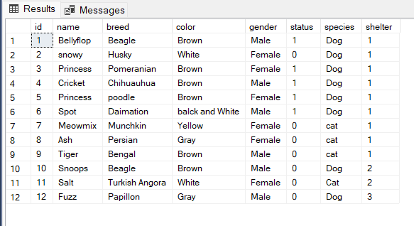

1. **Creating Index On Shelter**

**Query:** CREATE INDEX animal_shelter

ON animals (shelter);

**Output:**



1. **Joining the animal table with shelter table**

**Query:** SELECT * FROM animals

JOIN shelters

ON animals.shelter = shelters.id;

**Output:**

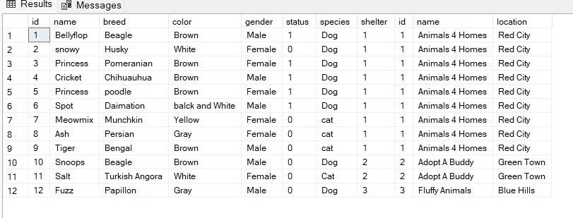

1. **Joining animal table with adoption table**

**1Query:** SELECT * FROM adoptions

JOIN animals

ON adoptions.animal_id = animals.id

WHERE animals.shelter = 1;

**Output:**

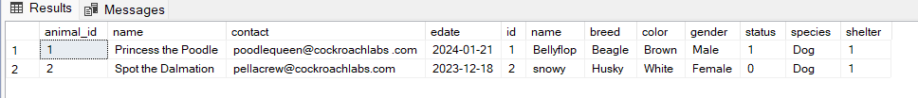

**19. Inserting data into adoption table**

**Query:** insert into adoptions values

(1,'Princess the Poodle','poodlequeen@cockroachlabs .com','2024-1-21'),

(2,'Spot the Dalmation','pellacrew@cockroachlabs.com','2023-12-18');

**Output:**

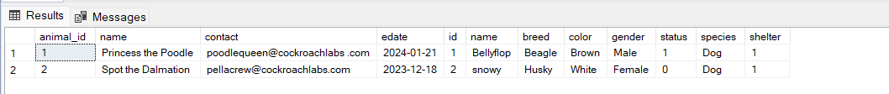

**20.Arranging the date of Adoption table in Descending order**

**Query:** SELECT * FROM adoptions

ORDER BY edate DESC;

**Output:**

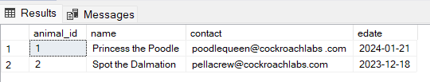

**21.Inserting data into shelter Table**

**Query:** INSERT INTO shelters (id, name, location)

VALUES

(1, 'Animals 4 Homes', 'Red City'),

(2, 'Adopt A Buddy', 'Green Town'),

(3, 'Fluffy Animals', 'Blue Hills');

**Output:**

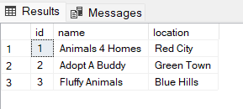

**---JOINS  
INNER JOIN**

**Query:** select

C.customerID,

C.customerName,

E.salary

from customers as C

Inner join employee As E

on C.customerID=E.customerID

group by C.customerID,c.customerName,E.salary;

**Output:**

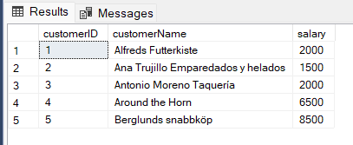

**LEFT JOIN**

**Query:** select

C.customerID,

C.customerName,

E.salary

from customers as C

Left join employee As E

on C.customerID=E.customerID

group by C.customerID,c.customerName,E.salary;

**Output:**

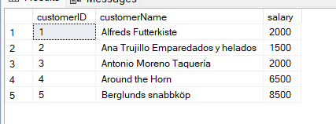

**RIGHT JOIN**

**Query:** select

C.customerID,

C.customerName,

E.salary

from customers as C

Right join employee As E

on C.customerID=E.customerID

group by C.customerID,c.customerName,E.salary;

**Output:**

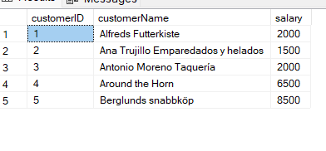

**FULL JOIN**

**Query:** select

C.customerID,

C.customerName,

E.salary,

E.age

from customers as C

Full join employee As E

on C.customerID=E.customerID

group by C.customerID,c.customerName,E.salary,E.age;

**Output:**

